Smart learning management system

Dear [Client],

We are excited to inform you that we have designed a learning management system that makes online teaching easier, more efficient, and organized. Our system aims to improve the interaction between teachers and students on the internet.

The user-friendly interface of our system makes it easy for both teachers and students to interact with it. This feature ensures that everyone can use the system with ease, and it promotes a seamless learning experience for all users.

We believe that our learning management system can revolutionize the way you teach online, and we are thrilled to offer it to you. We are confident that our system will exceed your expectations and help you achieve your teaching goals.

Thank you for considering our system. If you have any questions or concerns, please do not hesitate to reach out to us. We are always here to help.

Best regards,

……………………

System Overview:

Our project is presented with an 80% completed prototype, which means that it is almost ready to use. Additionally, new modules can be added according to the needs and preferences of our clients and users. This feature ensures that the system remains flexible and customizable to meet the ever-evolving demands of the industry.

One of the unique advantages of our system is that it does not rely on any external servers, as we have not used any frameworks for its development. As a result, breakdowns due to external influences are minimized, and a very high level of protection is provided to the system. This ensures that your data remains secure and protected at all times.

Moreover, we have included a user-friendly interface that makes it easy to handle user data in the database. This feature means that anyone with general IT knowledge can manage the data of the database without requiring any IT expertise. This functionality saves time and makes it easier to use the system, enabling you to focus on your core business objectives.

Thank you for your interest in our system project. If you have any questions or concerns, please feel free to contact us at any time. We are always here to help.

*General Features*

1. Login Interface

To access the system, simply enter your designated username and password into the login fields provided.

1. User Interface

Our system offers two interfaces, one for teachers and one for students. Both interfaces have been designed with the user in mind, ensuring an intuitive and user-friendly experience for all users.

* **Teacher interface**

The teacher interface offers the following features:

Classroom Tab

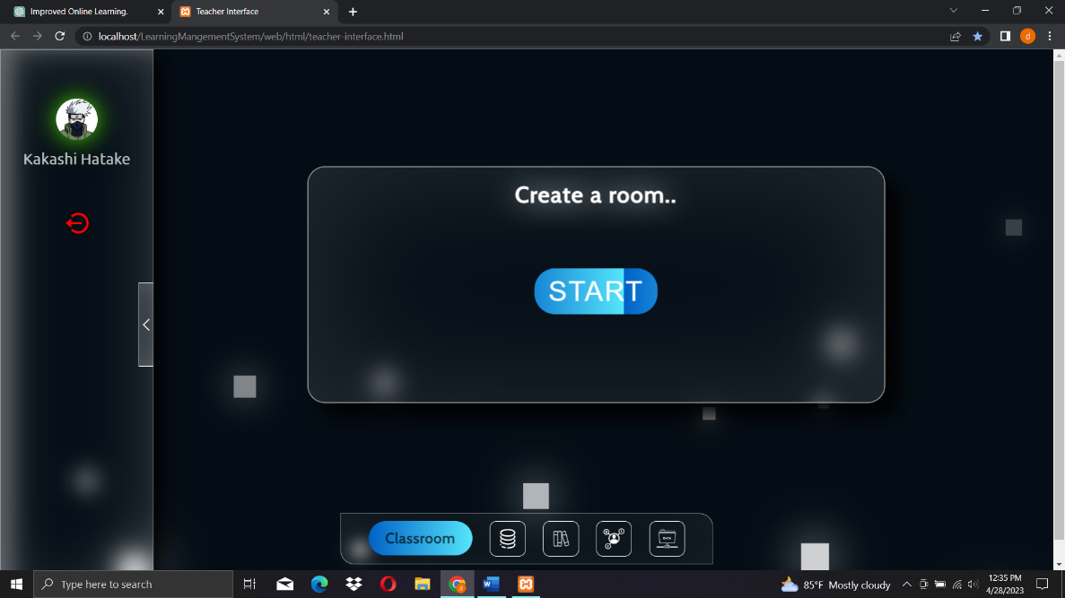

In this tab, teachers can start streaming classes, and students enrolled in the selected classes will be able to view the virtual room in real-time as soon as it is created.

Resources Tab

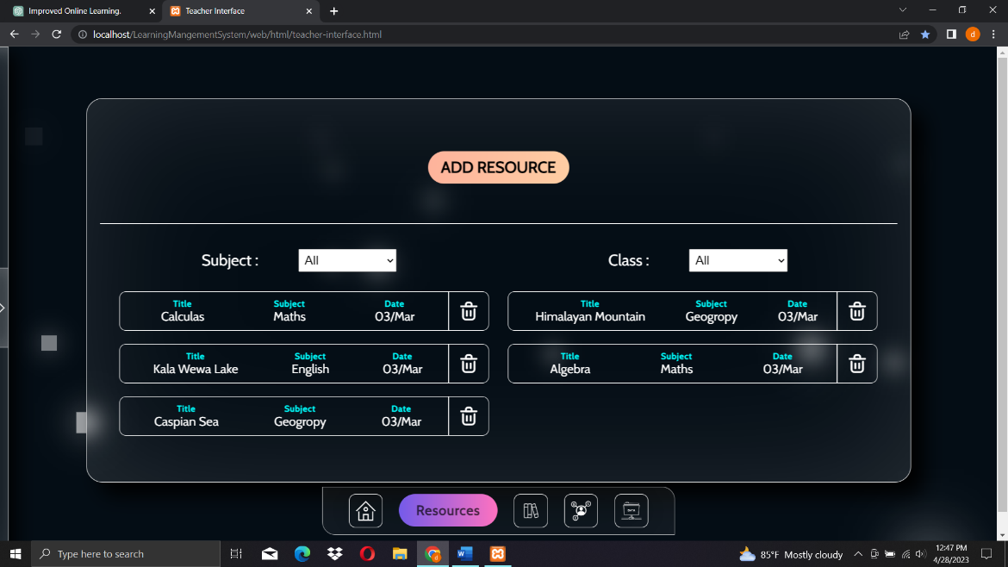

Using this tab, teachers can upload resources for their students in specific classes, ensuring that students have access to all the necessary materials to support their learning.

Homework Tab

With this tab, teachers can effortlessly upload homework assignments for their students, facilitating an organized and streamlined approach to assigning and submitting homework.

Community Tab

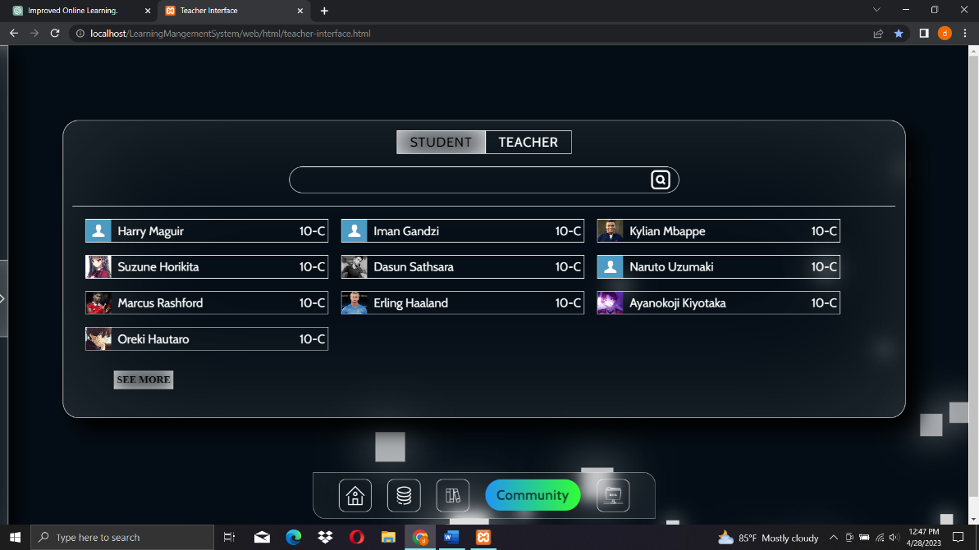

Users can see other students and teachers using this tab.

* **Student interface**

Classroom Tab

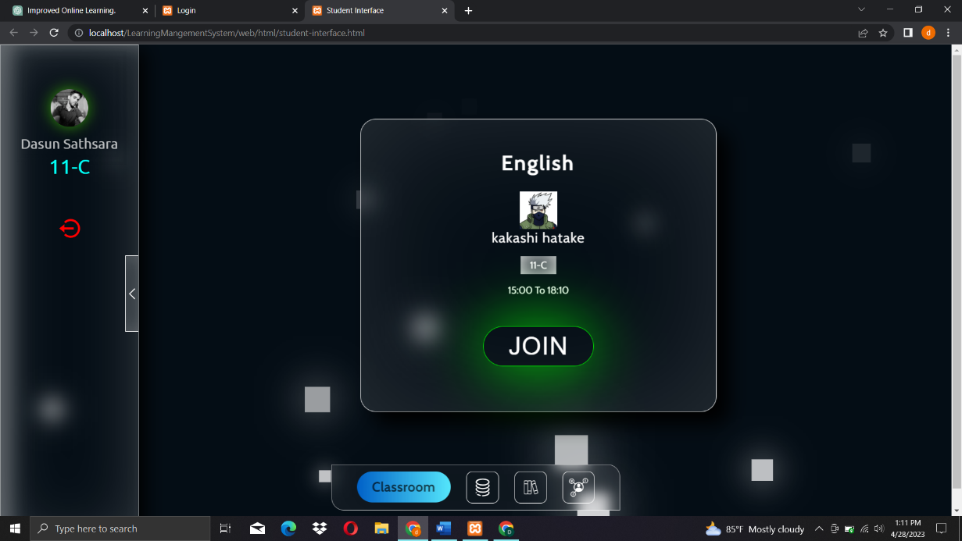

Once a teacher creates a virtual room for a specific class, it will appear in real-time on this tab. Users can effortlessly join the class by simply clicking the "join" button provided.

Resources Tab

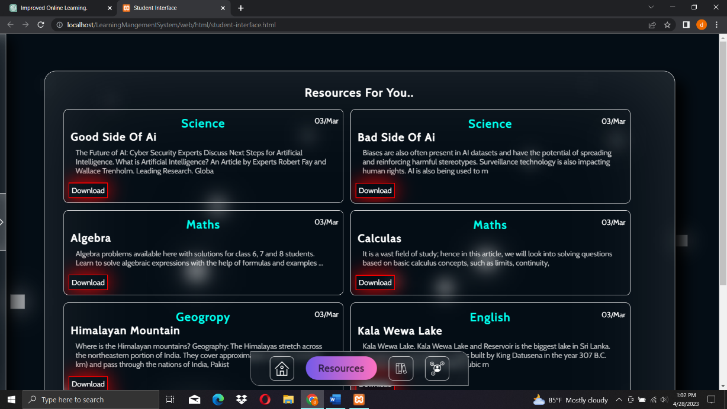

Through this tab, students have the ability to view and download any resources uploaded by their teachers, ensuring that they have access to all the necessary materials required to support their learning.

Homework Tab

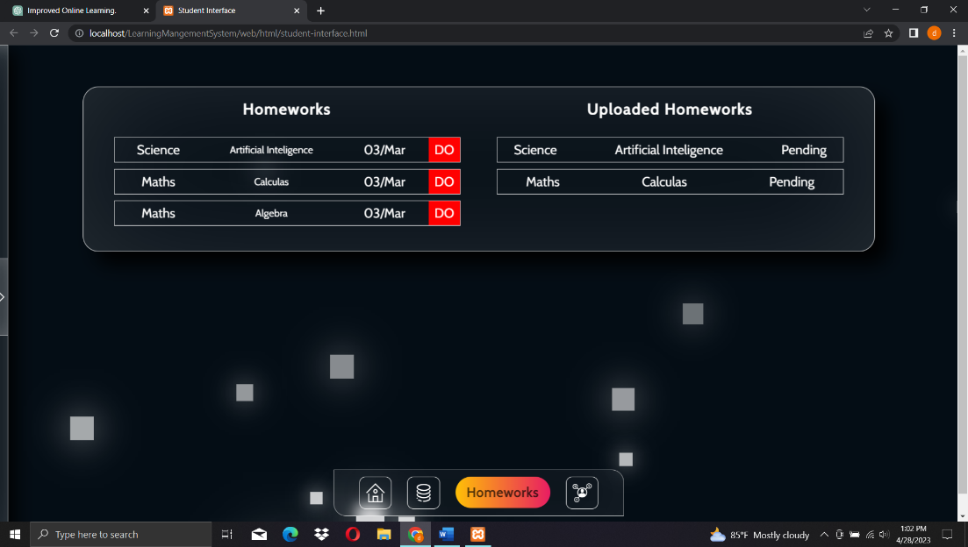

Students can view and download any homework assignments uploaded by their teachers, as well as to upload completed homework assignments that have been done by them. This feature promotes accountability and fosters a culture of learning, while enabling teachers to provide valuable feedback on student progress.

Community Tab

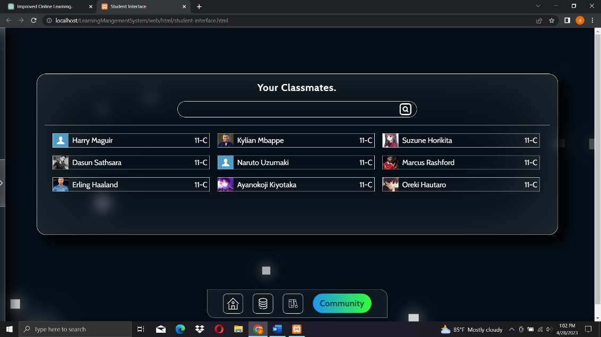

Students can their classmates using this tab

1. Database interface

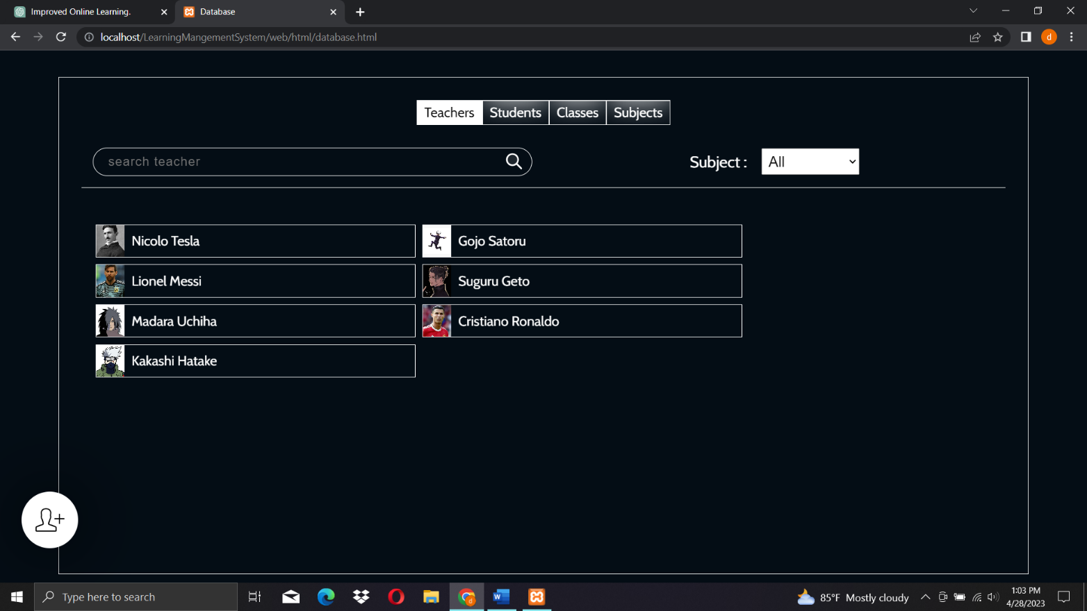

*Following features included in this interface:*

* Add new students and teachers
* Add new subjects and classes
* See and edit all user’s data